- SHP email address: dhs.ohs.shp@illinois.gov
- Homeless Portal Funding Plan due date: April 30th, 2026

- CSA Budget due date: May 15th, 2026

- Please do not forget to submit your FY27 Funding Plan attachments (as PDF) to @DHS.OHS.SHP by: May 15th, 2026
  - Include NICRA if applicable
  - Include subcontractor agreements
  - Uniform Application for Grant Assistance: Grant-Application-Blank.pdf (each contract requires its own Uniform Application for Grant Assistance)
  - Match is no longer required – ignore this message in the portal.

- SHP Contacts (Char Flickinger is no longer with the SHP program, please do not contact her regarding SHP)
  - dhs.ohs.shp@illinois.gov
  - @Kibe Pea, Eva @Allmon, Loveya
  - @Wakileh, Nisreen

- SHP CSA Training: April 29th @ 11:30. If you did not receive an invite please reach out to @Darnell, Jennifer

- Rejected/Late MGIs
  - If your agency’s MGI was rejected, please be sure to resubmit as soon as possible. Fiscal policy prohibits our team from processing payments out of order. Delays can create a back log.
  - When you submit your revised MGI, you must change the submission date on page 2 box KK to reflect the revised date of submission. If the date is not changed the MGI will be rejected again.
  - Failure to submit your MGIs and revisions in a timely manner may result in late payment, Court of Claims, or Stop Pay.

Thank you,

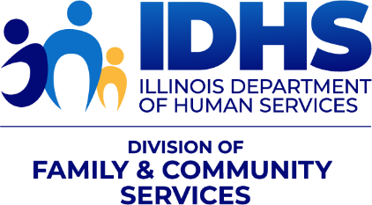 |  | Nisreen Wakileh, MBA/MSW  Bureau Administrator  Bureau of Permanent Housing  Office of Housing Stability  Illinois Department of Human Services  401 S Clinton St, Chicago, IL 60607  e: Nisreen.Wakileh2@illinois.gov

