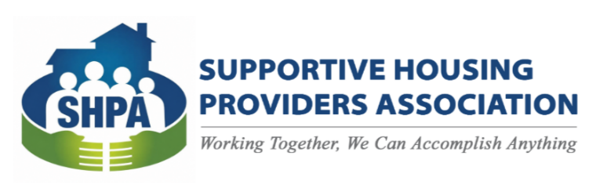
SPONSORSHIP LEVELS
Please contact info@shpa-il.org for more information.
Supportive Housing Providers Association | 6 Lawrence Square | Springfield, IL 62704
(217) 321 - 2467
2026 SHPA ANNUAL MEETING & SUMMIT
SPONSORSHIP OPPORTUNITIES
October 26th & 27th | President Abraham Lincoln Hotel - Springfield, IL

SH
$1,000

- 2 Free Registrations
- Exhibitor Table
- Logo recognition in program
RRH/TH
$500

- 1 Free Registration
- Exhibitor Table
- Logo recognition in program
HOMEOWNER
$5,000

- 8 Free Registrations
- Exhibit Space
- Logo recognition in all SHPA event marketing materials, website, and social media
PSH
$2,500

- 4 Free Registrations
- Exhibit Space
- Logo recognition in all SHPA event marketing materials, website, and social media
SRO
$350

- Logo recognition in program

EXCLUSIVE SPONSORSHIPS

*Includes Name & Logo on Conference Totes and/or Lanyards, complimentary registrations, recognition on website, program, and during the event. For more information contact info@shpa-il.org.
** Includes Peer Registration, Travel & Lodging.
Conference Totes $3,000*
Lanyards $1,500*
Peer Scholarships $ 500**

